**ARYAMAN MISHRA**

**19BCE1027**

1) import java.util.*;

class Thread1 extends Thread

{

int n;

Thread1(int n)

{

this.n=n;

}

public void run()

{

int d,sum=0;

while(n!=0)

{

d=n%10;

sum=sum*10+d;

n=n/10;

}

System.out.println("Reverse of Number="+sum);

}

}

class Thread2 extends Thread

{

int m;

Thread2(int m)

{

this.m=m;

}

public void run()

{

int i,fact=1;

for(i=1;i<=m;i++)

fact=fact*i;

System.out.println("Factorial="+fact);

}

}

public class OriginalThread

{

public static void main(String args[])

{

Scanner sc=new Scanner(System.in);

int n,m;

System.out.println("Enter a Number to Reverse a Number.");

n=sc.nextInt();

System.out.println("Enter a Number to find Factorial.");

m=sc.nextInt();

Thread1 t1 = new Thread1(n);

t1.start();

Thread2 t2 = new Thread2(m);

t2.start();

}

}

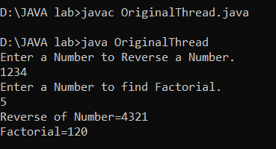

2) import java.util.*;

class InvalidAgeException extends Exception{

InvalidAgeException(String s){

super(s);

}

}

class Addressbook

{

public String name,address,pro;

public int age,salary;

Addressbook()

{

name="";

pro="";

age=0;

salary=0;

}

public Addressbook(int age,int salary,String name,String address,String pro)

{

this.age=age;

this.salary=salary;

this.name=name;

this.address=address;

this.pro=pro;

}

public void Person()

{

System.out.println("Name:"+name);

System.out.println("Age:"+age);

System.out.println("Salary:"+salary);

System.out.println("Address:"+address);

System.out.println("Profession:"+pro);

}

public static void main(String[] args) {

Scanner sc = new Scanner(System.in);

System.out.print("Enter number of People. ");

int n = sc.nextInt();

int i,a,b;

String c,d,e;

Addressbook[] arr=new Addressbook[n];

for(i=0;i<n;i++)

{

System.out.println("Enter Name.");

c=sc.next();

System.out.println("Enter Age.");

a=sc.nextInt();

System.out.println("Enter Salary.");

b=sc.nextInt();

sc.nextLine();

System.out.println("Enter Address.");

d=sc.nextLine();

System.out.println("Enter Profession.");

e=sc.nextLine();

sc.nextLine();

try {

if(a >= 100)

throw new InvalidAgeException("Age must be less than 100");

else

System.out.println("Valid age");

}

catch (InvalidAgeException ex) {

System.out.println(ex);

System.out.println("Enter Age again but less than 100.");

a=sc.nextInt();

}

arr[i]=new Addressbook(a,b,c,d,e);

}

for(i=0;i<n;i++)

{

arr[i].Person();

}

}

}

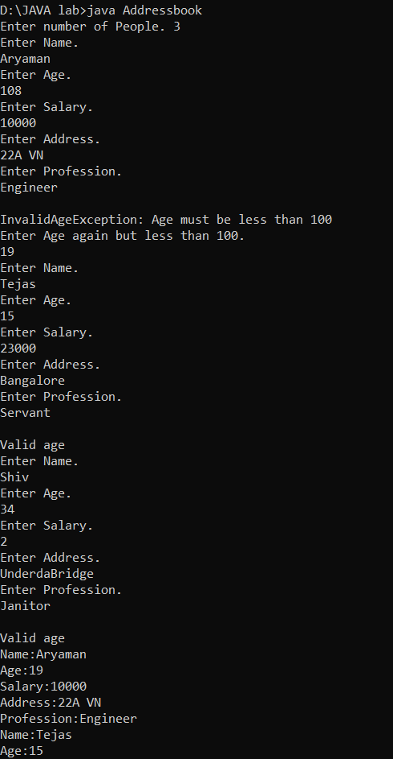

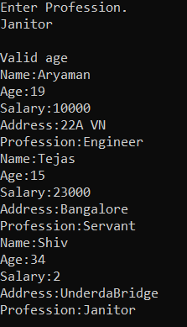

3) import java.io.IOException;

import java.io.RandomAccessFile;

import java.util.*;

public class RAF {

static final String FILEPATH ="Student.TXT";

public static void main(String[] args) {

Scanner sc=new Scanner(System.in);

System.out.println("Enter Student Number.");

int n=sc.nextInt();

try {

if(n==1)

System.out.println(new String(readFromFile(FILEPATH, 0, 4)));

if(n==2)

System.out.println(new String(readFromFile(FILEPATH, 4, 6)));

else

if(n==3)

System.out.println(new String(readFromFile(FILEPATH, 10, 8)));

else if(n==4)

System.out.println(new String(readFromFile(FILEPATH, 16, 8)));

else if(n==5)

System.out.println(new String(readFromFile(FILEPATH, 22, 8)));

} catch (IOException e) {

e.printStackTrace();

}

}

private static byte[] readFromFile(String filePath, int position, int size)

throws IOException {

RandomAccessFile file = new RandomAccessFile(filePath, "r");

file.seek(position);

byte[] bytes = new byte[size];

file.read(bytes);

file.close();

return bytes;

}

private static void writeToFile(String filePath, String data, int position)

throws IOException {

RandomAccessFile file = new RandomAccessFile(filePath, "rw");

file.seek(position);

file.write(data.getBytes());

file.close();

}

}

